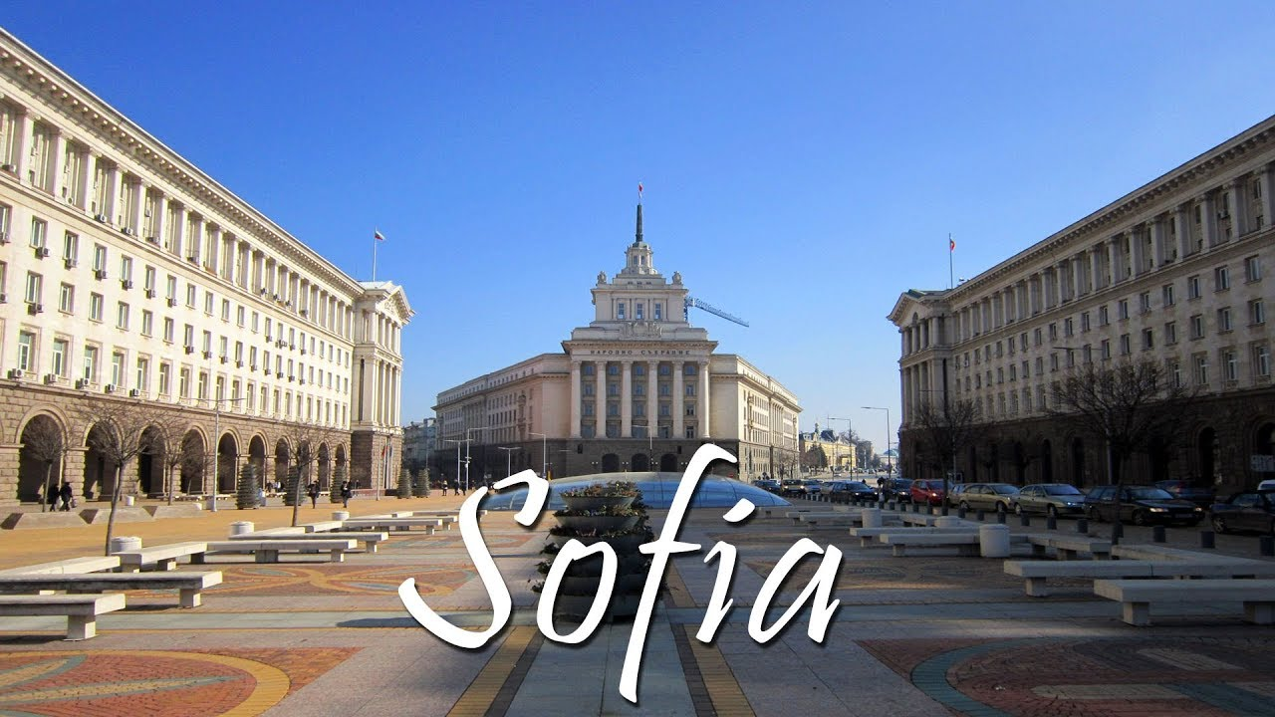
AGENDA
Meeting in SOFIA (Bulgaria)
Supervising Schools in the 21st Century: Digital Tools and Improvement Plans
SS21DTIP

Project Number: 2018-1-ES01-KA201-049937

Venue: Hall No. 1, Sofia University “St. Kliment Ohridski”, Rectorat, 15 Tsar Osvoboditel Blvd., Sofia 1504

Participants:
CEYE-JUNTAEX – Laura del Castillo Blanko and Ana Martin
Sofia University – Rossitsa Simeonova and Yonka Parvanova
DCU – Martin Brown and Gerry MacNamara
RPDE Stereas Elladas – Roula Kechri and Heleni Beniata

SCHEDULE for the second meeting in Sofia (Bulgaria)

WEDNESDAY 20th March 2019

SCHEDULE | ACTIVITY
9:00-12:30 | Opening and welcome  O1 comparative paper – agreement on the final version to be submitted for publication  O2 case study – discussing draft results for each country, comparison, structure of O2 paper
12:30-13:30 | LUNCH BREAK
13:30-16:00 | O2 case study – discussing draft results for each country, comparison, structure of O2 paper (cont.)
16:00-18:00 | Tour in Sofia center
18:00 | Dinner - Restaurant "Ariana 1904" https://ariana1904.com/en/home/

THURSDAY 21st March 2019

SCHEDULE | ACTIVITY
10:30-12:00 | Visit at 51st secondary school in Sofia –  https://sites.google.com/51school.bg/51school/home
12:00-14:00 | LUNCH BREAK
14:30-16:30 | visit at Regional Department of Education Sofia-city (former Regional Inspectorate of Education) – meeting with inspectors, exchanging good practices - http://ruo-sofia-grad.com/
18:00 | Dinner – Restaurant “O!Shipka” - http://www.oshipka.bg/en/restaurants/

FRIDAY 22nd March 2019

SCHEDULE | ACTIVITY
9:30-12:30 | O2 case study – discussing draft results for each country, comparison, structure of O2 paper (cont.) –if needed  Training event in Greece – dates, content, preparation of materials
12:30-13:30 | LUNCH BREAK
13:30-16:30 | Training event in Greece – dates, content, preparation of materials.  Financial and Dissemination information
16:30-18:30 | Sofia tour (optional)
18:30 | Dinner – Restaurant “O!Shipka” - http://www.oshipka.bg/en/restaurants/

